[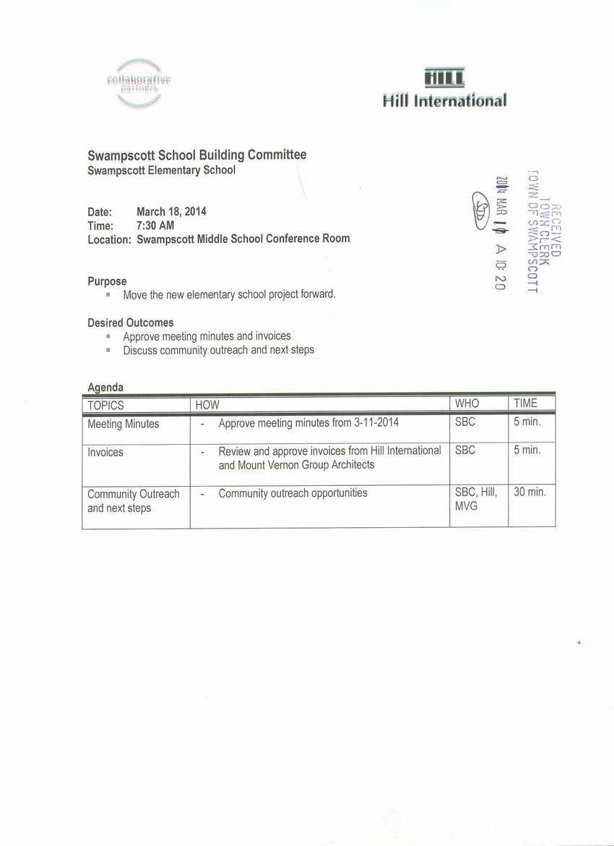](http://www.town.swampscott.ma.us/Public_Documents/SwampscottMA_Calendar/S046842A1-04684310.0/School%20Building%20Committee%20March%2018th%20notice%20001.jpg)